SQL QUERIES OF CAPSTONE PROJECT (CRIMES IN INDIA)

3.1 Insert records from 42_District_wise_crimes_committed_against_women_2001_2012.csv into a table

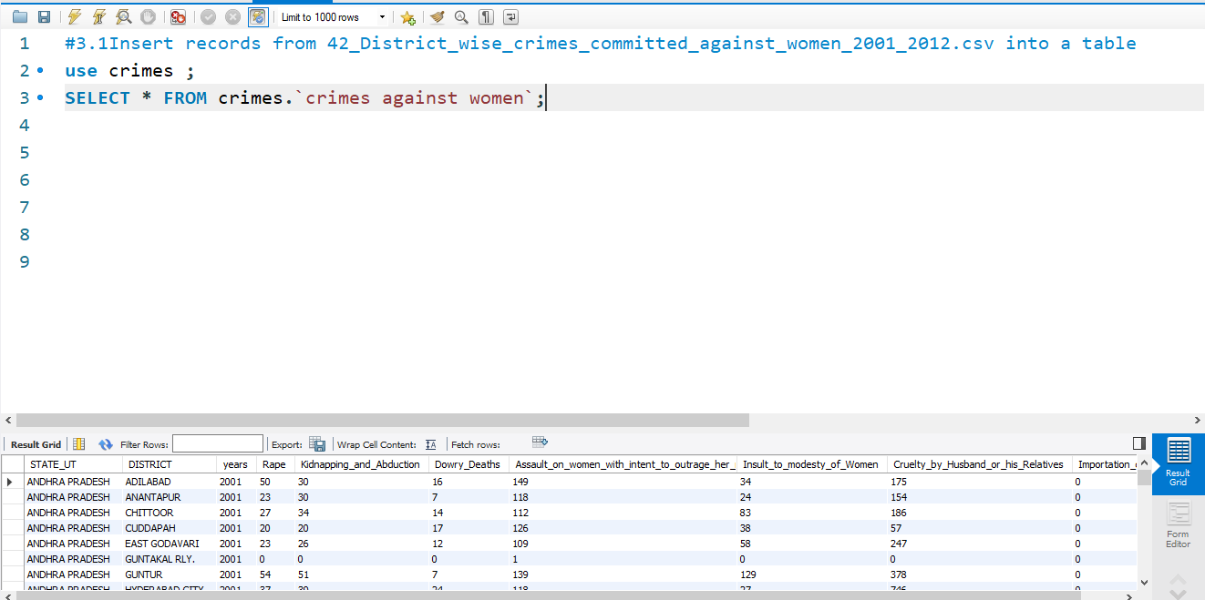

3.2 Write SQL query to find the highest number of rapes & Kidnappings that happened in which state, District, and year

3.2.1 find the highest number of rapes

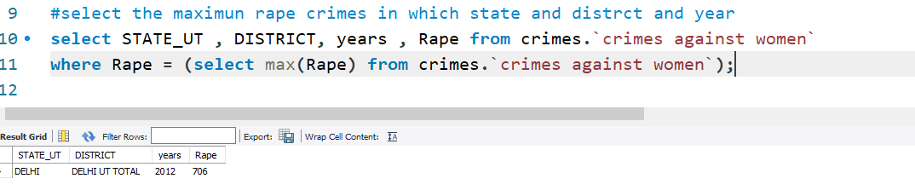

3.2.2 find the highest number of Kidnapping

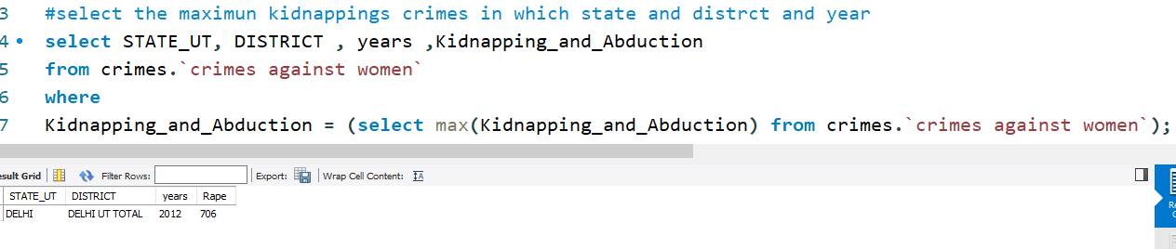

3.3 Write SQL query to find All the lowest number of rapes & Kidnappings that happened in which state, District, and year

3.3.1 find the lowest number of rapes against women

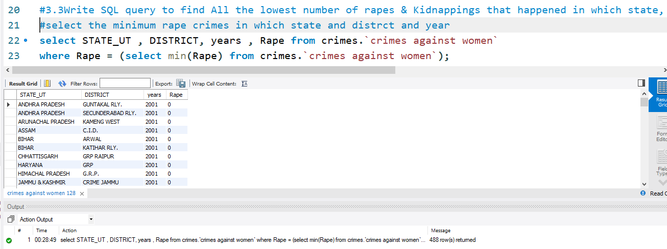

3.3.2 find the lowest number of kidnappings against women

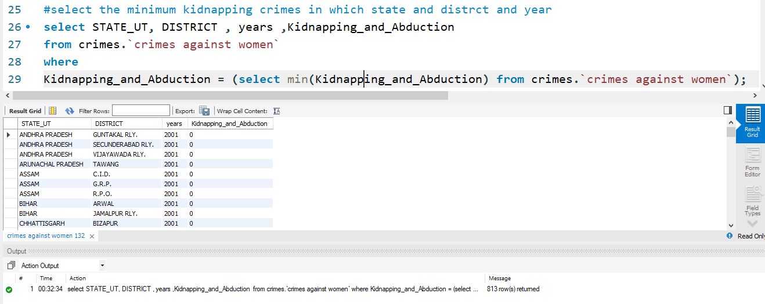

3.4 Insert records from 02_District_wise_crimes_committed_against_ST_2001_2012.csv into a new table

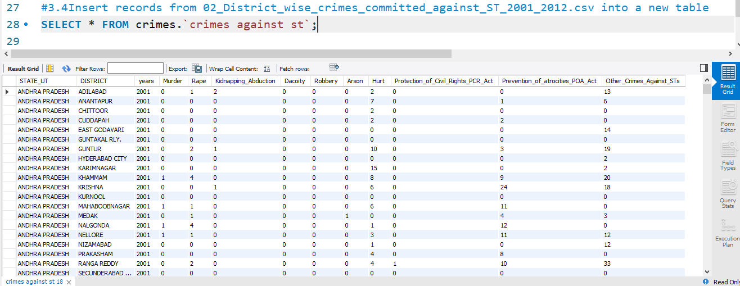

3.5 Write SQL query to find the highest number of dacoity/robbery in which district

3.5.1 find the highest number of dacoity in which strict

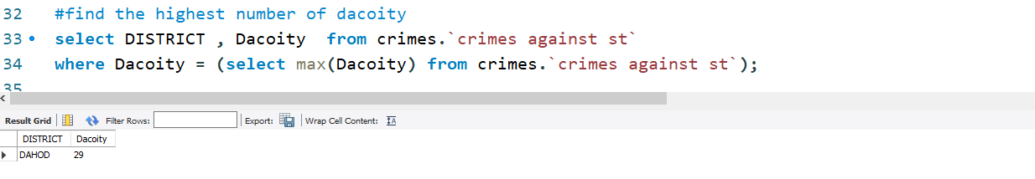

3.5.2 find the highest number of robbery in which district

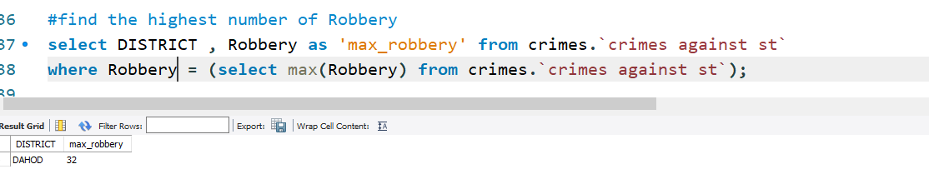

3.6 Write SQL query to find in which districts(All) the lowest number of murders happened

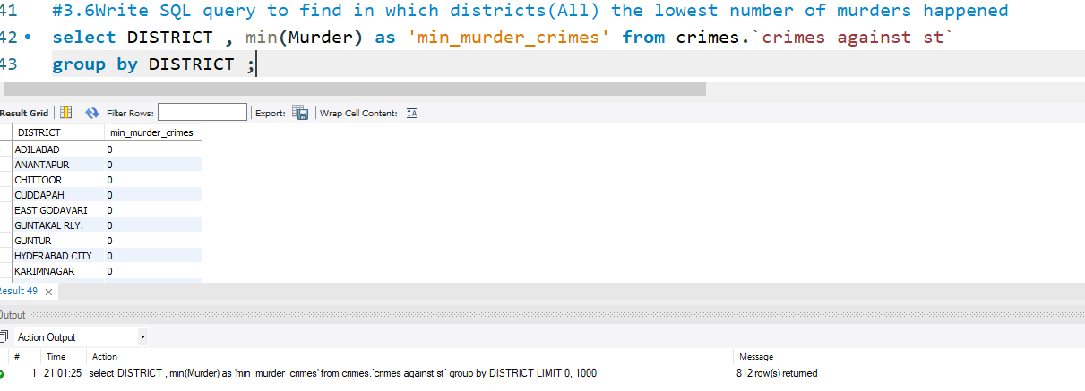

3.7 Write SQL query to find the number of murders in ascending order in district and yearwise

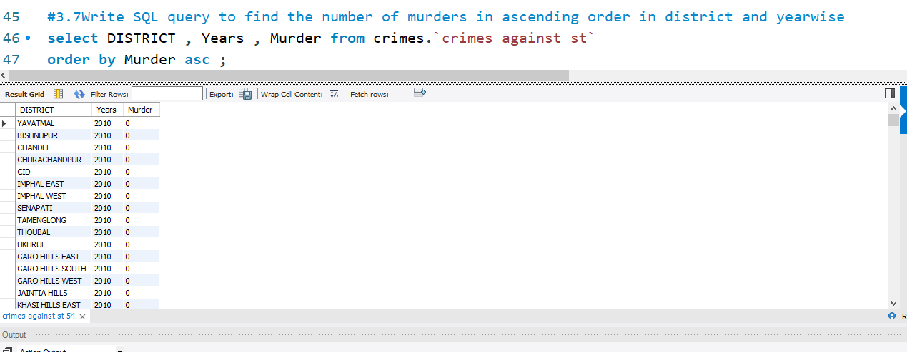

3.8.1 Insert records of STATE/UT, DISTRICT, YEAR, MURDER, ATTEMPT TO MURDER, and RAPE columns only from 01_District_wise_crimes_committed_IPC_2001_2012.csv into a new table

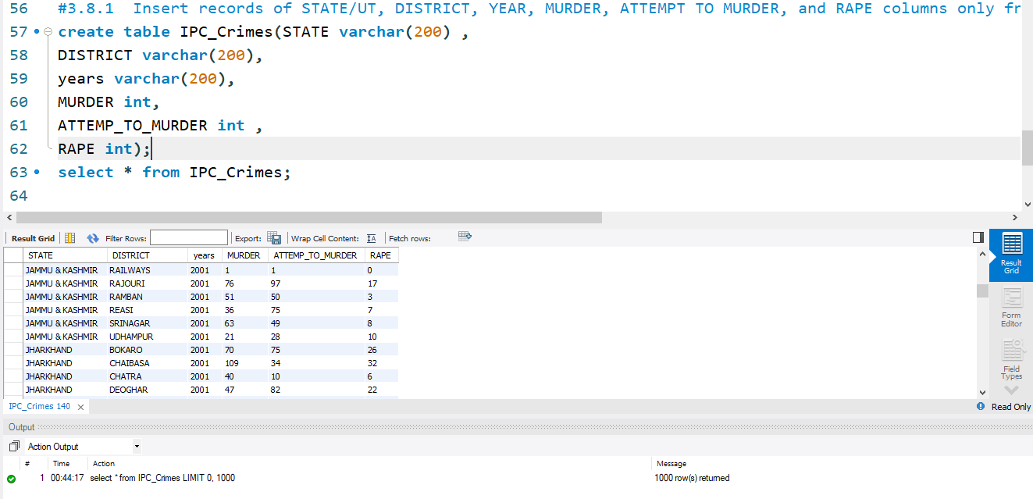

3.8.2 Write SQL query to find which District in each state/ut has the highest number of murders yearwise. Your output should show STATE/UT, YEAR, DISTRICT, and MURDERS.

